|  |  |  |
| --- | --- | --- |
| **LAB221 Assignment** | **Type:** | **Short Assignment** |
| **Code:** | **J2.S.P0021** |
| **LOC:** | **120** |
| **Slot(s):** | **2** |

**Title**

Courses management

**Background Context**

In fact, we often work with list of objects like student, staff, customers,… rather than individual value.

Course management will guide you how to manage a list of objects, also how to work with many frames at a time.

**Program Specifications**

Create an application by using java swing, the interface of application look like below figure.

***Function details:***

1. Display the main frame look like (1).
2. When users select a function from frame do corresponding task in individual dialog.

***Expectation of User interface:***

**CourseManagement.java**

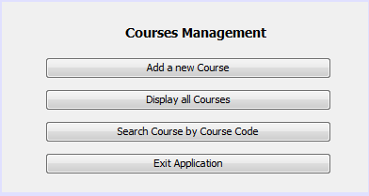 **(1)**

**AddCourse.java**

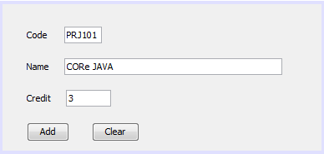

Requirements:

1. Code, name and credit cannot be empty.
2. Credit must be a positive number and less than or equals to 33.

**SearchCourse.java**

(Course name and credit are read only controls)

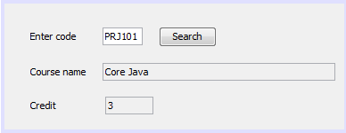

**ListCourse.java**

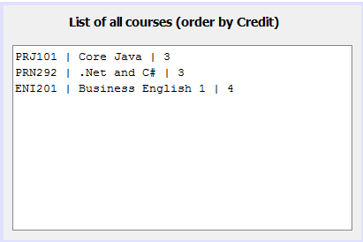

**Guidelines**